GUVI TASK 13

1. Login into IAM account
2. Create 2 instance for windows and linux

For linux – port 22,80

For windows – port 3389,80

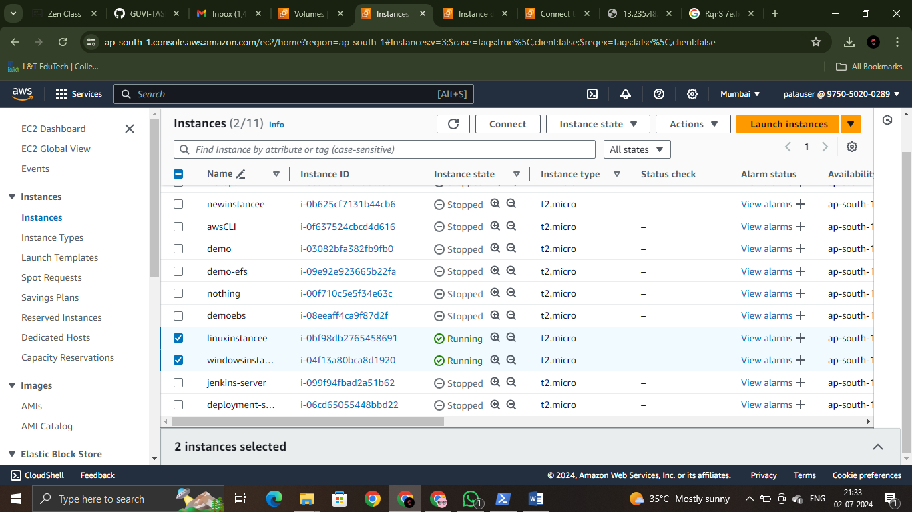

1. Open linux instance through ssh client

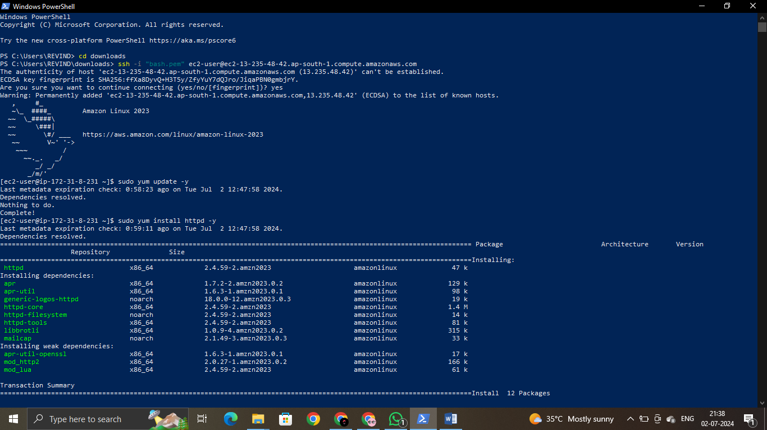

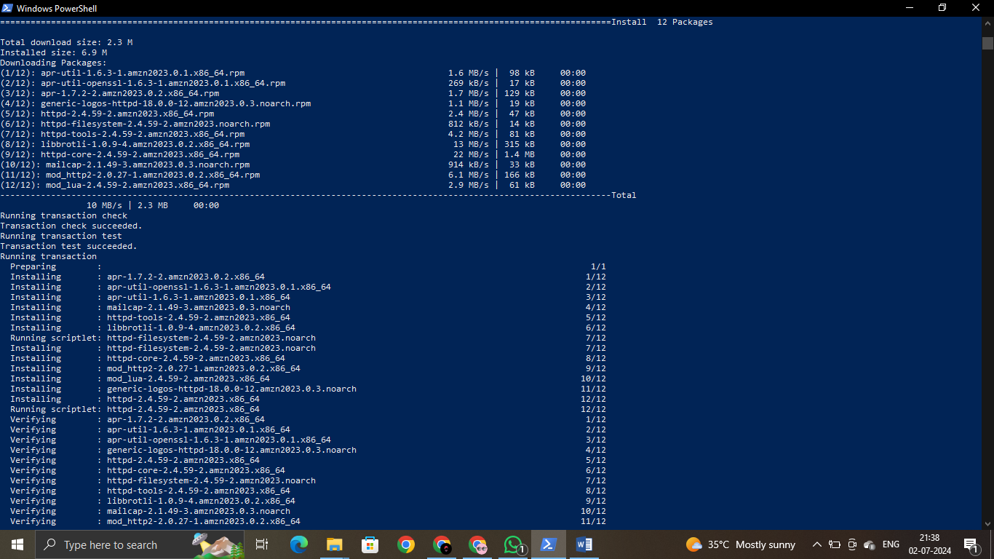

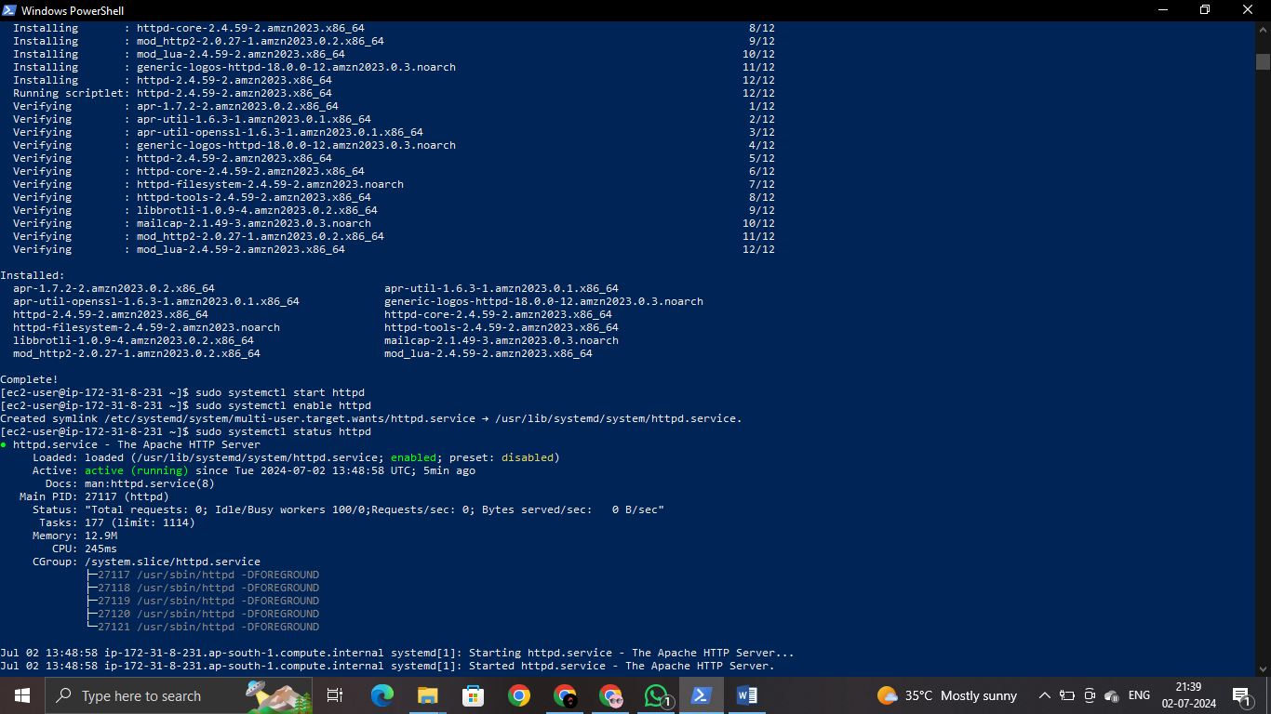

4.connect windows instance by downloading rdp file.

5.Then click that downloaded file. It asks for connect/cancel, click connect.

6.After connect it asks for admin password. For getting that password open your windows instance click connect , ssh client scroll down and see you will get the “get password” button. Click that. Then it asks for PEM file. Open your desktop and open that PEM key file. Then your instance automatically decrypts and give you the password. Copy that and paste it in admin dialog box then your windows VM opens. Then open powershell as administrator.

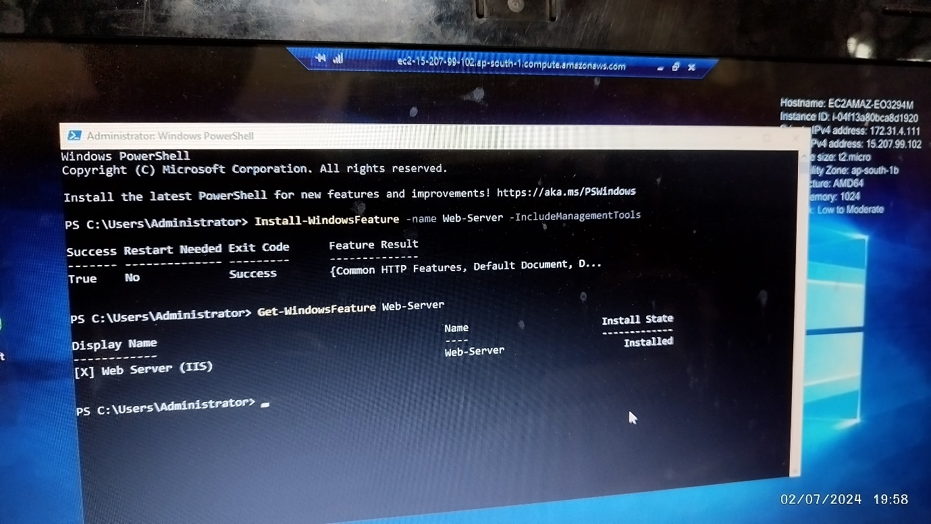

7. here we have installed IIS [internet information services] and check whether it has been installed or not.

8. next close this windows VM and open your ec2 console.

9. go to ebs volume.

10. create volume separately for linux instance and windows instance.

11. in these volumes give the availability zone according to which zone your instance is present, also storage should be given as 5GiB.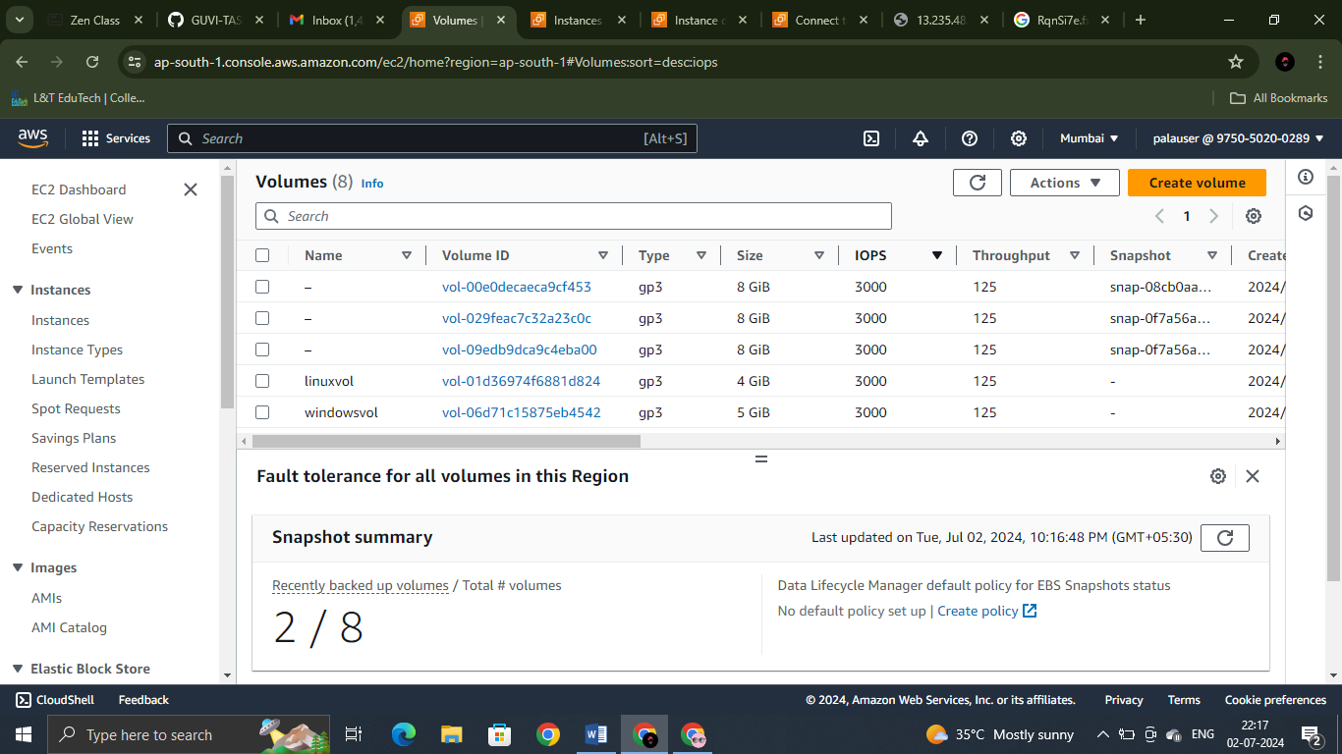

12. attach each volume to each instance with a device name. 13.device names will be given in the dropdown menu you can choose from it.

14. Do the same for windows instance also.

15.now connect your linux instance through ssh. This process is for format and mount.

Sudo mkfs -t ext4 /dev/xvdbb

Sudo mkdir /mnt/myvolume

Sudo mount /dev/xvdbb /mnt/myvolume

Here xvdbb stands for the device name I gave for the linux instance volume. [ I executed these three commands and I saw that the volume got mount but due to a sudden power cut that moment I was not able to take screenshot of it and paste it here. But I understood clearly how to mount our volume.]  
as it got mount through these commands itself I didn’t do fstab mount.

16. for mount in windows instance connect the instance through RDP.

17. do the same process explained in step 5,6 then your windows VM opens.

18. right click start button and open disk management.

19. there you will see a disk which shows offline with 5GB unallocated unknown.

20. right click that and initialize the disk.

21. it shows a series of steps, complete it.

22. then it shows disk is online and healthy. So this process is over so close windows VM.

23. next create a snapshot

24. I tried creating snapshot by choosing both volume but that didn’t work. So I created two snapshots.

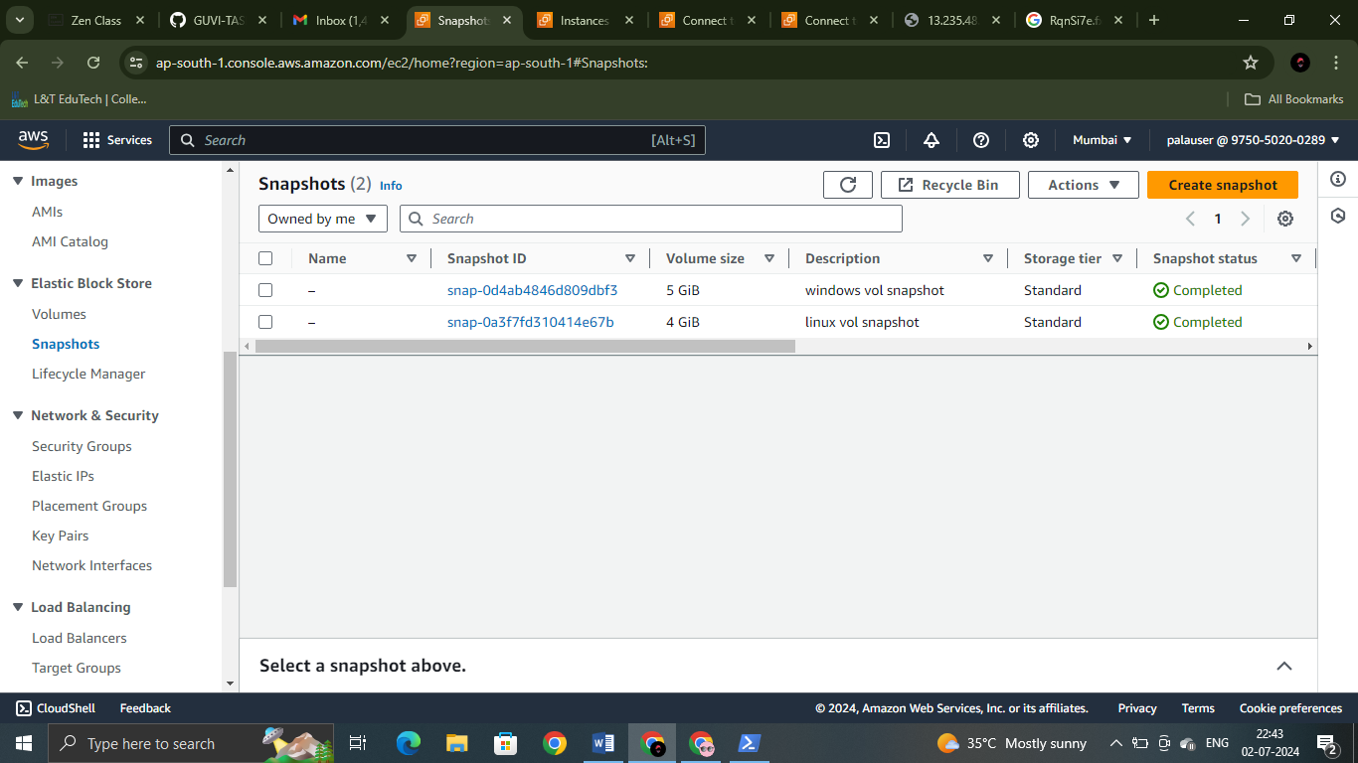

25. next to create a EBS volume from the snapshots. As we cannot combine both snapshots and create one volume so I created two separate volume from both snapshots.

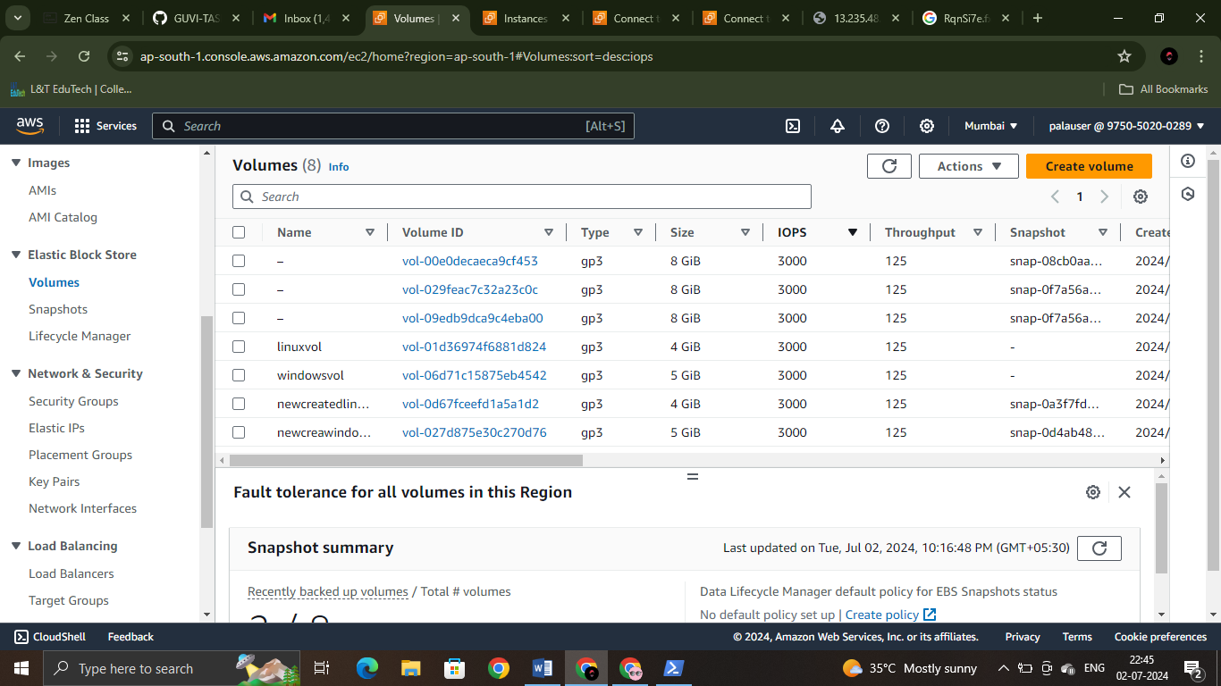

26. after this I got confused whether why should I connect the newly created volume again to the instances I have created in the beginning that is linux and windows instance .

We cannot connect one volume to 2 instance also. So I stopped the task with this.

-----X-----